Emily McMahon
ITM-617
6 May 2026

Predicting the Impact of Earnings on Stock Price Movement
Introduction
Financial markets react rapidly to corporate earnings announcements, as investors use earnings results to evaluate company performance and future growth expectations. One commonly analyzed concept is earnings surprise, which represents the difference between a company’s reported earnings per share (EPS) and analyst expectations. Positive earnings surprises are often associated with upward stock price movement, while negative surprises may lead to declines. However, stock market reactions are influenced by many additional factors, including investor sentiment, market conditions, and future company guidance, making short-term price prediction highly complex. This project examines whether earnings-related variables alone can be used to predict short-term stock price movement following earnings announcements. Historical stock price and earnings datasets were merged and processed to create custom variables measuring EPS surprise, absolute surprise magnitude, and percentage surprise relative to analyst expectations. These variables were then compared against short-term stock price changes surrounding earnings events. Multiple analytical approaches were applied to include linear regression, classification modeling and hierarchical clustering. The goal of the analysis was to evaluate the predictive strength of earnings surprise measures and explore broader patterns in market reactions following earnings announcement
Data
The dataset used in this analysis consists of historical stock price data and corporate earnings announcement data. The stock price dataset included daily market information such as opening price, closing price, adjusted closing price, trading volume, and stock ticker symbols. The earnings dataset included company ticker symbols, earnings announcement dates, reported earnings per share (EPS), and estimated EPS. The datasets were cleaned and merged using ticker symbols and event-based date alignment to identify stock prices immediately before and after each earnings announcement. New variables were then constructed, including earnings surprise, absolute earnings surprise, surprise percentage, stock price percentage change, and a binary variable indicating whether the stock price increased following the earnings announcement. To improve efficiency, the analysis was conducted using a filtered subset of the overall dataset and selected variables relevant to stock price reaction analysis. The prepared dataset was then used for predictive modeling and clustering techniques to evaluate relationships between earnings surprises and short-term stock price movements.
Methodology
The datasets were cleaned and prepared prior to analysis by handling missing and invalid values. Infinite values created during percentage calculations were replaced with missing values and incomplete observations were removed. Relevant variables were selected and the data was divided into training and testing datasets using an 80/20 split. Feature scaling using standardization was also applied prior to predictive modeling to ensure variables were on a consistent scale. Several new variables were created to evaluate earnings announcement reactions. Earnings surprise was calculated as the difference between reported EPS and estimated EPS, while absolute surprise and surprise percentage variables were generated to measure the size of the earnings surprise. Stock prices immediately before and after earnings announcements were used to calculate percentage stock price change. A binary variable labeled ‘went_up’ was also created to indicate whether the stock price increased following the earnings announcement. Additionally, earnings surprises were grouped into ranges to support exploratory statistical analysis. Exploratory analysis was conducted to examine relationships between earnings surprise variables and stock price reactions. Summary statistics were generated across EPS surprise ranges to evaluate average stock price movement and the probability of positive returns. Scatterplots and a correlation matrix were also used to visualize relationships among variables and identify trends, outliers, and overall correlation strength prior to predictive modeling.
Linear Regression was used to evaluate whether earnings surprise variables could predict the magnitude of short-term stock price changes following earnings announcements. The model used earnings surprise, absolute surprise, and surprise percentage as predictor variables, with percentage stock price change serving as the target variable. Model performance was evaluated using R², Mean Absolute Error (MAE), and Root Mean Squared Error (RMSE). Two classification models, Logistic Regression and Random Forest, were applied to predict whether stock prices increased or declined following earnings announcements. The binary ‘went_up’ variable served as the target variable for both models. Logistic Regression was selected as a baseline classification approach due to its interpretability, while Random Forest was chosen for its ability to capture nonlinear relationships and interactions between variables. Model performance was evaluated using accuracy, precision, recall, F1-score, confusion matrices, and ROC/AUC curves. Hierarchical clustering was applied as an exploratory unsupervised learning technique to identify potential groupings among earnings events based on earnings surprise characteristics and stock price reactions. The selected variables were standardized prior to clustering, and Ward linkage was used to minimize within-cluster variance. Due to computational limitations associated with the large dataset size, clustering was performed on a random sample of 500 observations. A dendrogram was then generated to visualize similarities and separation between clusters.
Results
The exploratory analysis showed weak overall relationships between earnings surprise variables and short-term stock price reactions. The scatterplot indicated a very weak relationship between EPS surprise metrics and percentage stock price change, with the observations widely dispersed and no clear linear trend. This suggests that earnings surprise alone may not strongly explain market movement following earnings announcements.
The Linear Regression model also demonstrated very weak predictive performance, producing a negative R² value (-0.0004), indicating that the model explained virtually none of the variation in stock price changes. The relatively high MAE and RMSE (0.0596 and 0.1081) indicate substantial prediction error and limited ability to estimate the impact of short-term stock returns. The predictor variables seen in the correlation matrix in Figure 1, showed extremely weak correlations, with almost all coefficients close to zero. This further supports that earnings surprise alone has little to no relationship with short-term stock price movement. Although, the variable ‘abs_surprise’ showed to have a moderate correlation, it is still not enough to demonstrate a meaning predictive strength.
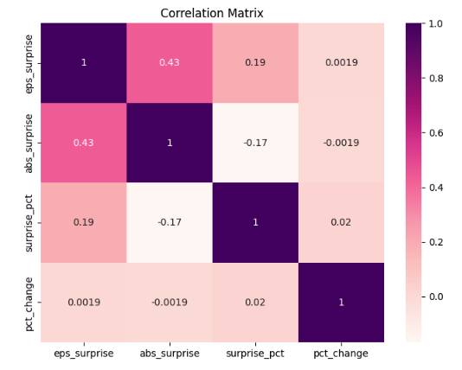
Figure 1: Correlation Matrix
The classification models produced slightly stronger results but still demonstrated limited predictive capability overall. The Random Forest model achieved an accuracy of 56.82% with a balanced performance across both classes. Precision, recall and F1-score were all approximately 0.57 for both upward and downward movement. This indicates that the model classified both outcomes relatively equal without favoring one over the other. This performance suggests that the Random Forest model was more stable in identifying both positive and negative stock movements, although the overall predictive strength was weak.
The Logistic Regression model achieved an accuracy of 56.34%, but the classification metrics revealed a different pattern. The model performed much better at predicting upward stock movement, with. Recall of 0.85 and an F1-score of 0.66 for positive predictions. The performance for downward stock price predictions was much weaker, with a recall of 0.28 and an F1-score of 0.39. This indicates that the Logistic Regression model showed a strong tendency to predict positive stock movement which struggling to correctly identify downward movements. For a financial classification problem such as stock movement prediction, accuracy alone is not the most reliable evaluation metric. This is because stock price direction is highly volatile and even the smallest class imbalances or prediction biases can distort accuracy results. Metrics such as recall, precision, and F1-score provide more meaningful insight into how well the model identifies each class individually. In this case, F1-score is especially important because it balances both precision and recall, making it more useful for evaluating whether the model can consistently identify upward and downward stock movements without heavily favoring one outcome.
The AUC scores of both models as seen in Figure 2, further confirmed the limited predictive strength. The Random Forest model achieved an AUC score of 0.58, while Logistic Regression achieved a slightly stronger AUC score of 0.63. Since an AUC score of 0.50 represents random guessing, both models only performed only slightly better than chance, indicating weak overall predictability. Although Logistic Regression produced a higher AUC score, its strong bias toward predicting positive movement reduced its overall reliability compared to the more balanced Random Forest model.
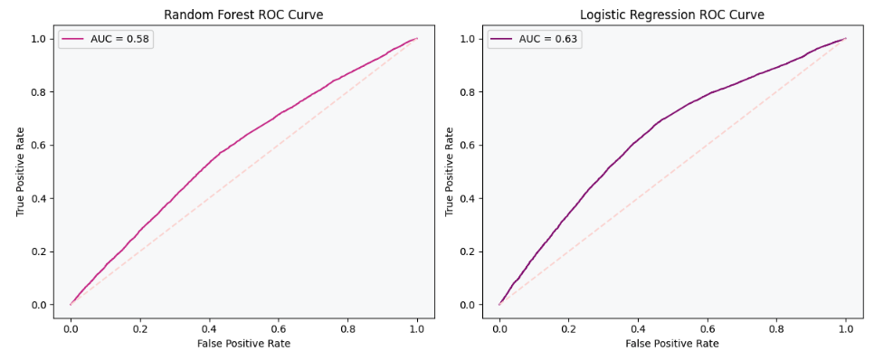
Figure 2: Classification Model ROC Curve
Feature importance analysis from the Random Forest model identified ‘surprise _pct’ as the most influential predictor variable, contributing substantially more to the model than EPS surprise or absolute surprise measures. This suggests that the impact of an earnings surprise compared to expectations may have a stronger relationship with short-term stock price reactions than the actual earnings difference itself. However, despite being the strongest predictor, the variable still did not provide enough explanatory power to produce highly accurate classifications.
Hierarchical clustering and the dendrogram visualization suggested the presence of several moderately distinct groupings among earnings events, although substantial overlap remained between many observations. This indicates that while some earnings announcements shared similar behavioral patterns, the overall structure of the data was not strongly separated into clearly defined clusters. The overlap between clusters suggests that stock reactions to earnings announcements are influenced by additional external factors beyond EPS surprise measures alone, such as market sentiment, macroeconomic conditions, industry trends, or investor expectations. As a result, the clustering analysis further supports the conclusion that earnings surprise variables by themselves provide limited predictive power for explaining short-term stock price movements.
Discussion
The results of this analysis suggest that earnings surprise variables alone are not strong predictors of short-term stock price movement. While positive and negative earnings surprises are commonly associated with market reactions, the models demonstrated only weak predictive performance across both regression and classification tasks. This indicates that stock price behavior following earnings announcements is influenced by many additional factors beyond reported earnings results. The relatively weak correlations and low model performance likely reflect the complexity of financial markets, where investor sentiment, broader market conditions, company guidance, industry trends, and macroeconomic events can all influence stock prices simultaneously. In many cases, earnings expectations may already be incorporated into stock prices prior to the announcement, limiting the impact of the reported earnings surprise itself.
Although predictive performance was limited, the analysis still provided valuable insights into market behavior. The Random Forest feature importance analysis suggested that percentage-based earnings surprise measures may contain more predictive information than raw EPS surprise values alone. The clustering analysis highlighted the variability and overlap that exist among earnings reactions, reinforcing the difficulty of consistently predicting short-term market movement using only a limited set of variables. Future model building could be improved by incorporating additional market indicators such as trading volume, analyst sentiment, volatility measures, broader economic conditions, and textual analysis of earnings calls or financial news.
Limitations
Several limitations were present in this analysis. First, the models relied primarily on earnings surprise-related variables and did not include other factors that commonly influence stock prices, such as macroeconomic conditions, investor sentiment, company guidance, industry performance, or broader market trends. Additionally, stock market data is highly volatile and influenced by unpredictable external events, making short-term price prediction inherently difficult. The large size of the dataset also created computational limitations, particularly for hierarchical clustering, which required the use of a smaller random sample rather than the full dataset. Finally, the analysis focused only on short-term stock reactions surrounding earnings announcements and did not evaluate longer-term market performance following earnings events.
Conclusion
Overall, the results demonstrated weak predictive relationships between earnings surprise variables and short-term stock price reactions. While the classification models slightly outperformed the regression model, predictive performance remained relatively limited across all approaches. The findings suggest that earnings surprise metrics alone are insufficient for reliably predicting market movement, highlighting the complexity and uncertainty of financial markets. Future research incorporating additional financial, economic, and sentiment-based variables may improve predictive performance and provide deeper insight into stock market behavior following earnings announcements.

